Yale School of Arts
Proyecto por: Carlos Martínez López

1. Contenidos de la página principal
Main Title:
The Yale School Of Art
Nav:
• Home
• About the School
• Apply to the School
• Exhibitions
• Publications
• News
• Public Events
Section:
The School of Art is one of Yale’s Graduate & Professional Schools conferring MFA degrees in Graphic Design …
Quick Links
Otros Sections:
• Happening at SOA
• Community Bulletin Board
• Calendars and newsletter
Footer:
• Links: Instagram, Facebook, YouTube
• Content is the property of its various authors...

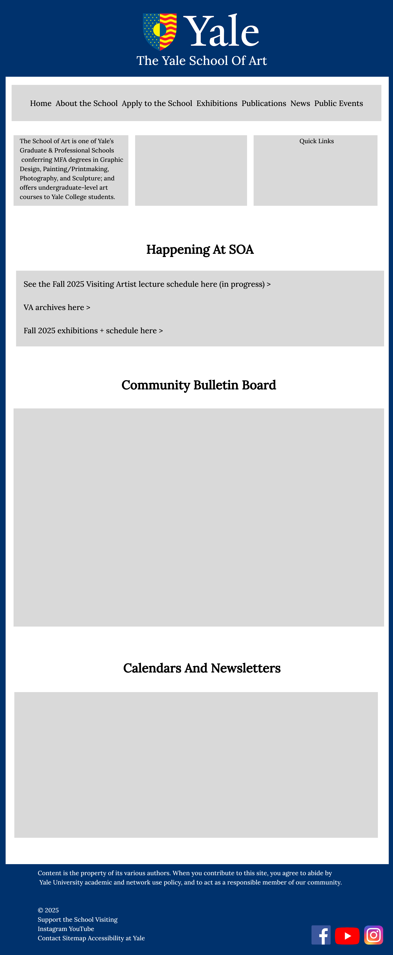
1.Mockup:

2.Layout
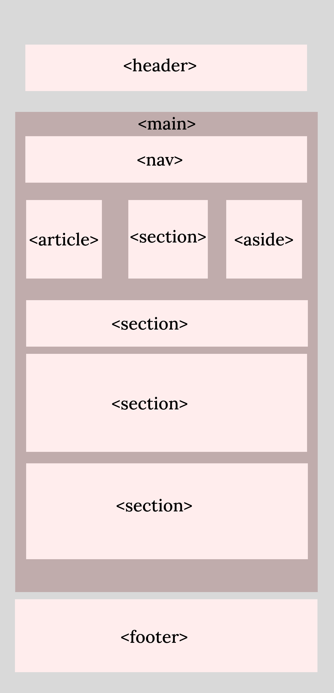

3.Guía de estilos

Logo: Colores:


rgb(0, 51, 110)


rgb(255, 255, 255)


rgb(204, 204, 204)

Fuentes:
Lora: p,a,li...
Lora Bold: h2,h1

